**Assignment**

Rajasekhar Devineni

University of the Cumberlands

Artificial Intelligence for Human-Computer Interaction

Prof. Alan Dennis

August 01, 2025

**AI-Based Adaptive Human-Computer Interaction: A Sentiment-Aware Chatbot**

**Introduction**

Adaptive user interfaces can be changed based on the interactions of a user, changing either the layout, the content, or the behaviour of the interface. These interfaces are not fixed, unlike the rest, during the design process, but are dynamic. The adaptive interfaces aim to promote more user engagement, accessibility, and natural interaction. The means of proving this idea with the help of artificial intelligence was a simple adaptive chatbot. The chatbot managed to improve the overall communication experience as it adjusted the response to the tone of emotional input of the user.

**Adaptive User Interfaces**

Behaviour-based systems or systems that adapt to the way an individual uses them are known as adaptive user interfaces. They modify whatever they exhibit or how they react when the person is utilizing them. As an example, a site may simplify things to a person who is using it for the first time and then express more advanced features after they have become accustomed to it. In this exercise, the chatbot adjusted its response in regard to the tone in the messages that the user sent (Ruiz et al., 2021). Such a modest modification allowed the voice pattern to seem more intimate and appropriate to the mood of the user.

**Intelligent UI**

Artificial intelligence Applications: Intelligent user interfaces employ artificial intelligence methods to improve interaction between the user and the computer. These interfaces may have complex features like reasoning, learning, or prediction (Schmidt et al., 2021). All intelligent interfaces are of a possible structure, which all have adaptive content, but may not necessarily employ intelligent decision-making in all adaptive interfaces. Smart user interfaces incr.ease the flexibility of a system through analysis of data, pattern recognition, or even language comprehension. The chatbot system was smart in a systematic way that it identified the sentiment in the user input and generated an adequate response, hence being responsive to changes and intelligent in its behavior.

**AI-Based HCI**

Adaptive human-computer interaction through artificial intelligence. Artificial intelligence is applied in adaptive human-computer interaction, where the system's behavior is dynamically changed during user interaction. In this project, AI was used to analyze the emotional polarity of a user's text input (Kotian & Nandipi, 2024). Depending on the analysis, the chatbot varied its tone of reply, being either supportive, helpful, or neutral. This interaction model was constructed of a simple decision structure based on natural language processing, which allows emotional awareness in real-time communication.

**Project Steps**

Installed the needed libraries with the command-line software

The natural language corpora vocabulary used in sentiment analysis was downloaded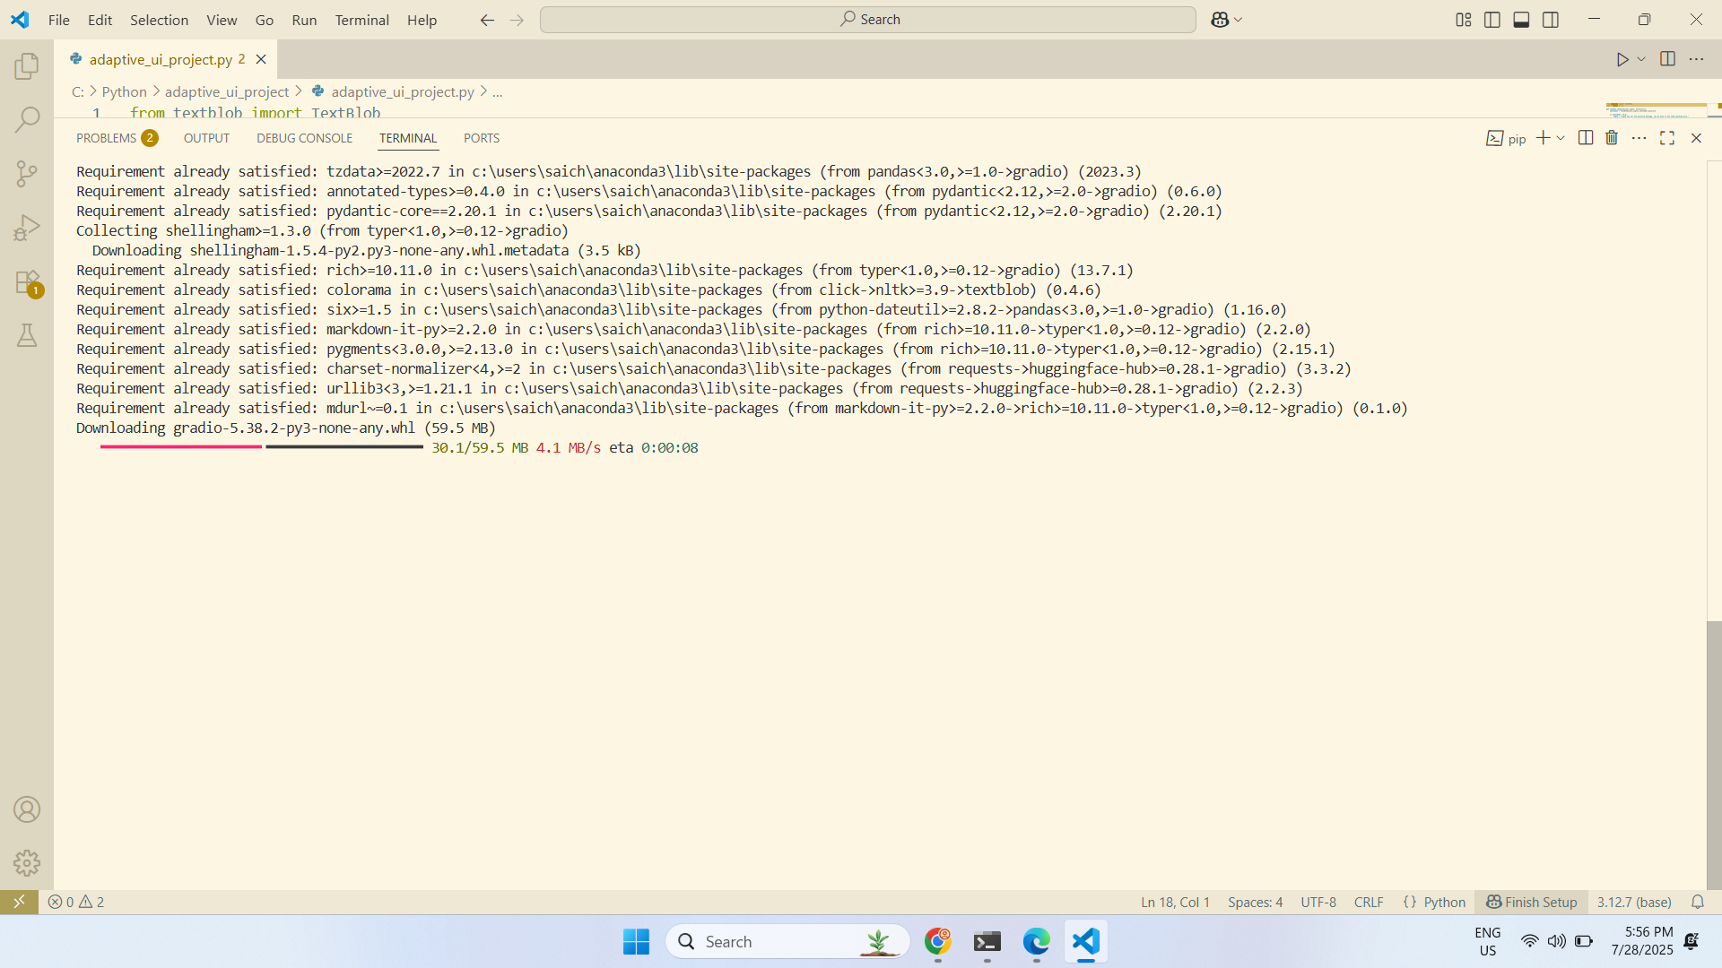

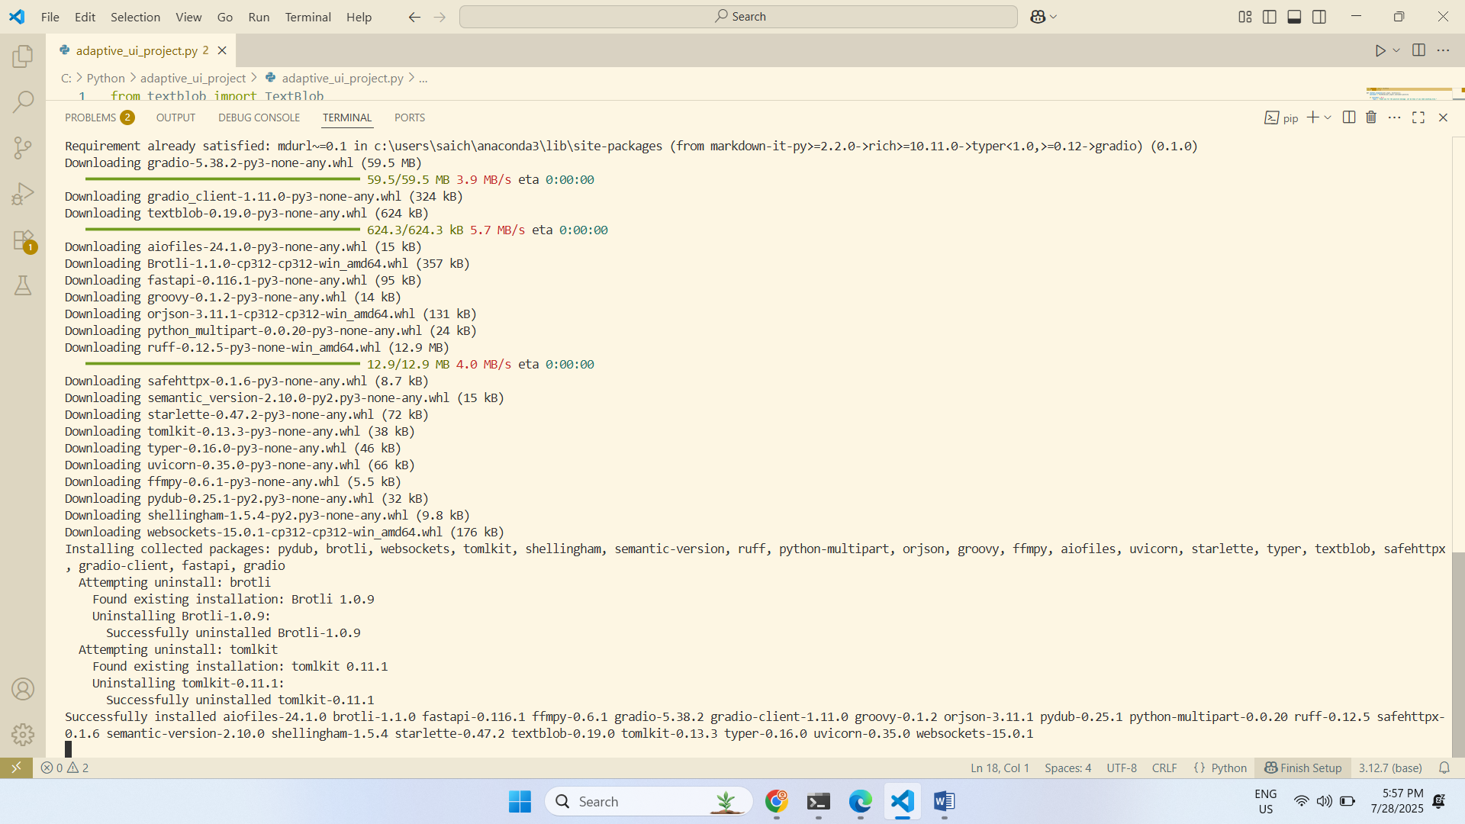

Coded a Python program to analyze messages by users and identify sentiment

Developed logic to classify the sentiment as positive, neutral, or negative

Created designed responses phrases by sentiment category

Created a chatbot via the web browser with Gradio Blocks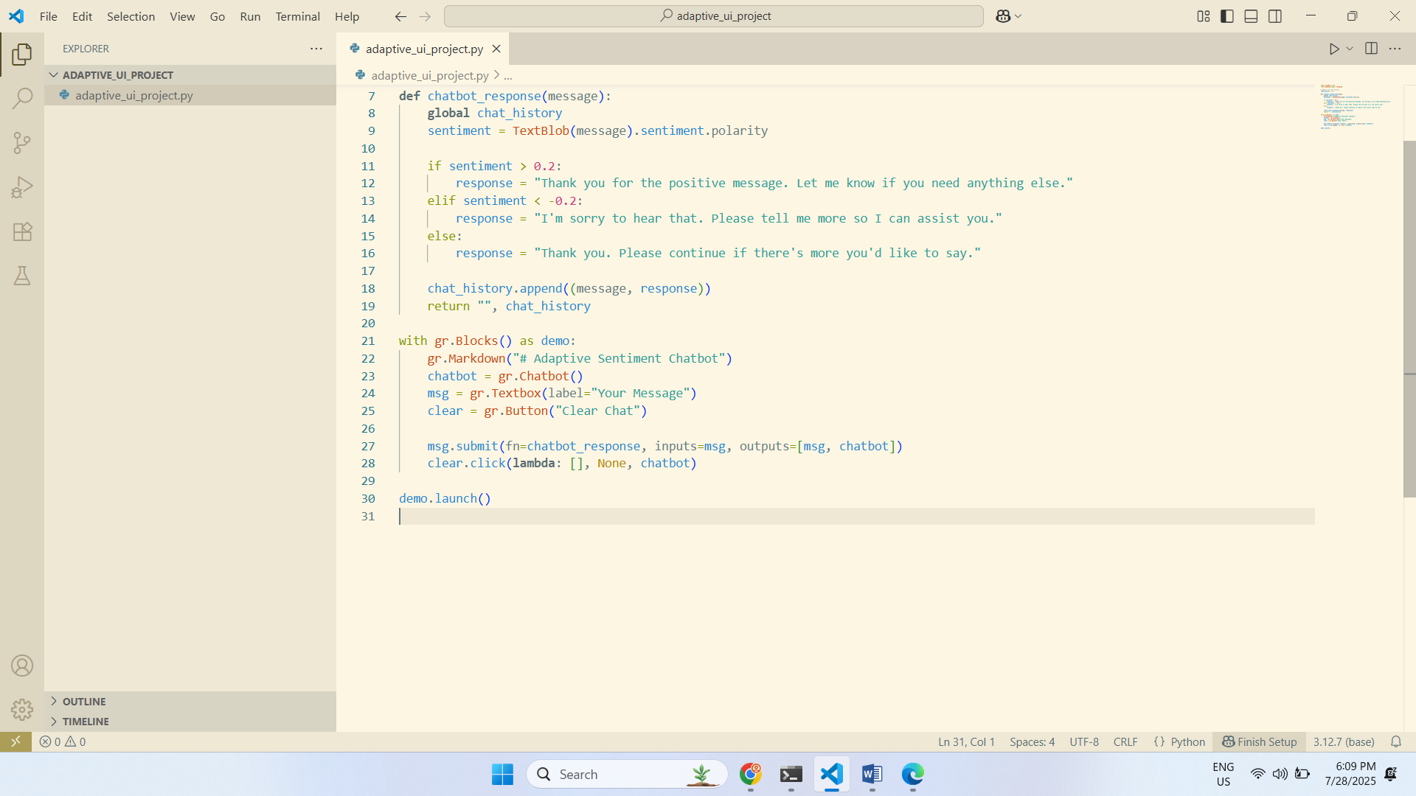

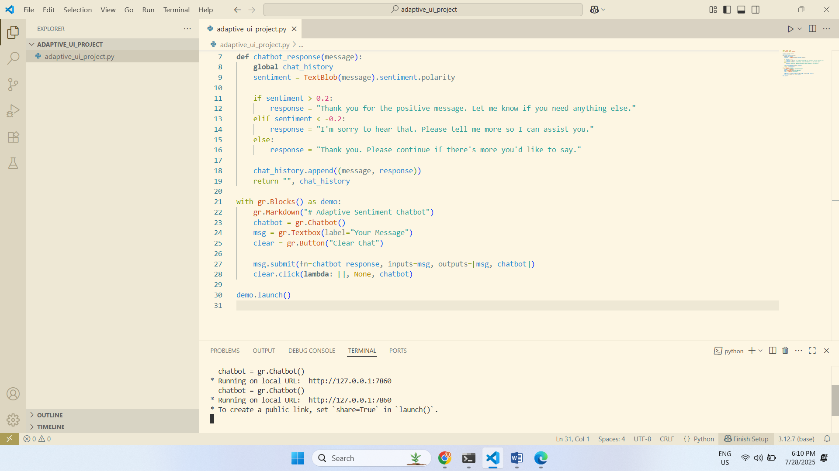

Arranged the chatbot to take user data and respond dynamically to it

There is now an explicit reset chat history button

Applied several inputs into the chatbot to verify behavior adaptation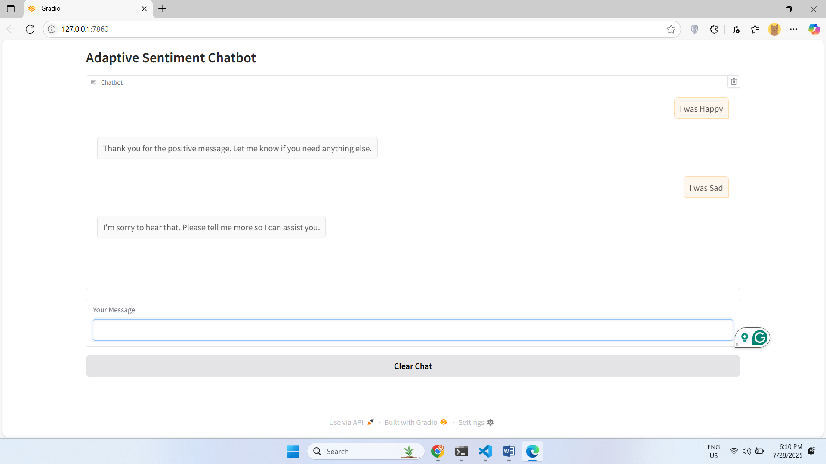

**User Experience**

User experience is enhanced by the use of artificial intelligence since it establishes systems that react dynamically to users based on their actions, feelings, or preferences. In the developed Chabot, AI allowed responding to emotions by identifying the sentiment. This enabled the system to give more context-dependent and human-like responses. By adapting behaviour, it is possible to minimize friction, maximize satisfaction, and develop trust by demonstrating that the system adapts to the way people feel. Even simple AI functions have the potential to enhance human contact to a significant degree by providing appropriate and helpful responses.

**Real Life Applications of Adaptive Interfaces**

There are several adaptive systems in the daily digital venues. Email clients provide the proposed responses that are based on previous language use. Streaming services would suggest a movie or a show depending on what was previously watched. Online GPS alters directions based on the traffic and mode of transport. Such systems personalise information or interface structure that becomes more service-oriented to individual users. Adaptive behaviour minimizes the effort made by the users and maximizes the participation, which does not need to be configured manually.

**Challenges Faced**

Sometimes, there was a problem with the inconsistency between the initial design of the Chabot and the most recent Radio library. The formatting message technique became obsolete. The solution to this problem was to rewrite this Chabot with new Gradio Blocks and Chabot components. The other problem was the detection of sentiment of very short or ambiguous user messages. When this is the case, sentiment analysis comes out neutral. To fix this, message templates were chosen according to types of sentiments, and response categories were thoroughly defined. These changes to the systems were tested to make sure they were stable.

**Technologies and AI Tools Applied**

The programming language that was used in the solution is Python. The browser-based interface was created with the help of gradio, which is based on simple blocks of text and input fields. Sentiment analysis was done using TextBlob to identify whether a message contained positive, neutral, or negative information. This interface was pure text and did not need a graphic element. The development based on the project has employed open-source packages, and commercial tools have never been used.

**Conclusion**

The process of building an adaptive chatbot and artificial intelligence with Python proved to be a good case showing the overall principles of an adaptive and intelligent user interface. The system changed behaviour according to the sentiment of the user and provided the right replies. The chatbot managed to have personalized interaction, and it did so through the use of natural language processing with minimal infrastructure. The current project demonstrated that basic AI integration may greatly enhance user experience by responding to changes and emotional states. Intelligent and adaptive interface technologies are still finding their development, and they are likely to play a greater part in future applications.

**References**

Kotian, A. L., & Nandipi, R. (2024, January). A systematic review on human and computer interaction. In 2024 2nd International Conference on Intelligent Data Communication Technologies and Internet of Things (IDCIoT) (pp. 1214-1218). IEEE.

Ruiz, J., Serral, E., & Snoeck, M. (2021). Unifying functional user interface design principles. International Journal of Human–Computer Interaction, 37(1), 47-67.

Schmidt, A., Mayer, S., & Buschek, D. (2021, May). Introduction to intelligent user interfaces. In Extended Abstracts of the 2021 CHI Conference on Human Factors in Computing Systems (pp. 1-4).